**TECHNOLOGICAL INSTITUTE OF THE PHILIPPINES**

**938 Aurora Blvd., Cubao, Quezon City**

**COMPUTER ENGINEERING DEPARTMENT**

1st Semester S.Y. 2020 – 2021

**FINAL CASE STUDY**

**Junaid M. Bantuas**

**Student**

**Engr. Alonica R. Villanueva**

**Instructor**

**Network Automation**

**Planned Automation: Implementation of VLANS**

**Initial Design of Network structure on Packet Tracer**

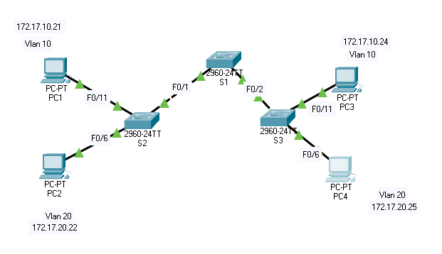

Figure 1.0 Initial Draft Design

This design was first tested in packet tracer to ensure that the planned system would work when it is finalized for use in the actual case study.

Table 1.0 Addressing Table

| **Device** | **Interface** | **Ip Address** | **Subnet Mask** | **Default Gateway** |
| --- | --- | --- | --- | --- |
| S1 | VLAN 99 | 172.17.99.11 | 255.255.255.0 | N/A |
| S2 | VLAN 99 | 172.17.99.12 | 255.255.255.0 | N/A |
| S3 | VLAN 99 | 172.17.99.13 | 255.255.255.0 | N/A |
| PC1 | NIC | 172.17.10.21 | 255.255.255.0 | 172.17.10.1 |
| PC2 | NIC | 172.17.20.22 | 255.255.255.0 | 172.17.20.1 |
| PC3 | NIC | 172.17.10.24 | 255.255.255.0 | 172.17.10.1 |
| PC4 | NIC | 172.17.20.25 | 255.255.255.0 | 172.17.20.1 |

Table 1.1 Port Assignments

| **Ports Assignment Network** | **Ports Assignment Network** | **Ports Assignment Network** |
| --- | --- | --- |
| Fa0/1 – 0/5 | 802.1q Trunks (Native VLAN 99) | 172.17.99.0 /24 |
| Fa0/6 – 0/10 | VLAN 20 – Students | 172.17.20.0 /24 |
| Fa0/11 – 0/17 | VLAN 10 – Faculty | 172.17.10.0 /24 |

Ansible Automation Code

---

# This playbook will create vlans 10, 20, and 99 on all switches.

- hosts: CSR1kv

gather_facts: false

connection: local

vars:

cli:

username: cisco

password: cisco123!

vlans:

10: "Faculty"

20: "Students"

99: "Management"

tasks:

- name: create vlans

ios_config:

provider: "{{cli}}"

lines:

- name {{item.value}}

parents:

- vlan {{item.key}}

with_dict: "{{vlans}}"

- name: show vlan brief

ios_command:

provider: "{{cli}}"

commands: show vlan brief

register: vlan_brief

- name: print output to screen

debug:

var=vlan_brief.stdout_lines

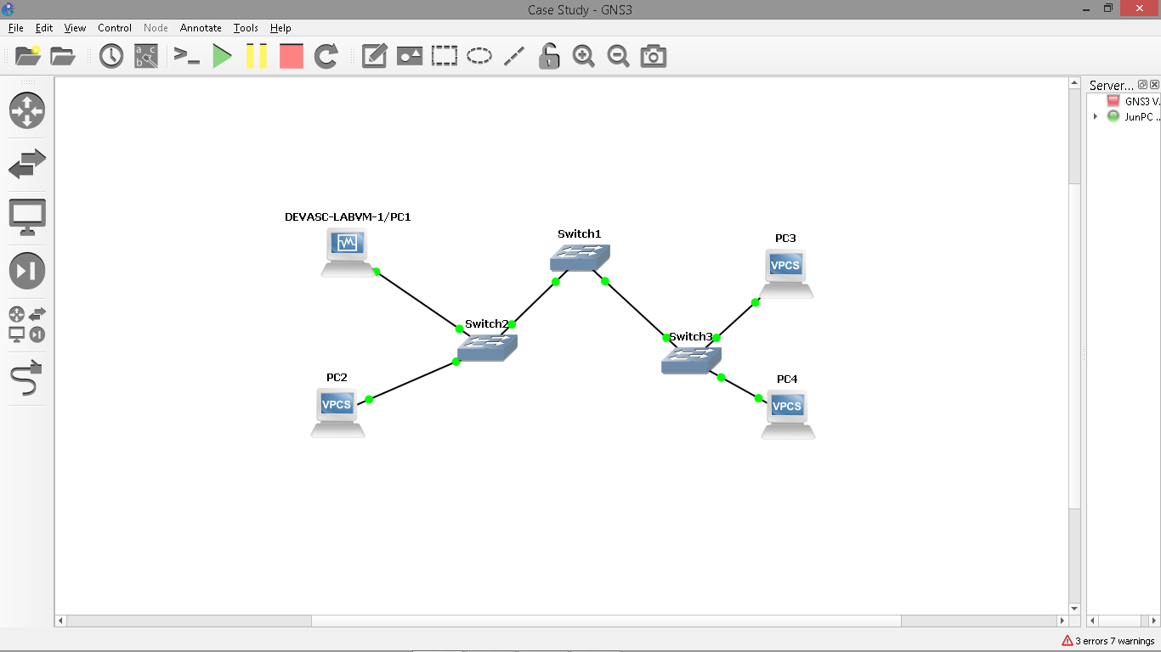

Figure 1.1 Implementing on GNS3

There are 4 PCs, with PC1 being the DEVASC Machine. With 3 switches connecting different sites. PC1 and PC3 are VLAN 10 while PC2 and PC4 are VLAN 20.